CREATE A DATABASE IN CLOUDANT DB

|  |  |
| --- | --- |
| **Name** | **Aparna Bhuvanesvari L** |
| **Register Number** | **710719106006** |
| **Project Name** | **Project - IOT based safety gadget for child safety monitoring and**  **notification** |
| **Maximum Marks** | **4 Marks** |

**Create a Database In Cloudant DB**

**Aim**:

To create a database in Cloudant DB to store location data.

Steps followed:

* Logged in to IBM Cloud account
* Navigated to `./resources`
* Clicked on the “Create Resource +” button
* Searched for “Cloudant”
* Chose the “Lite Version” and clicked on “Create”

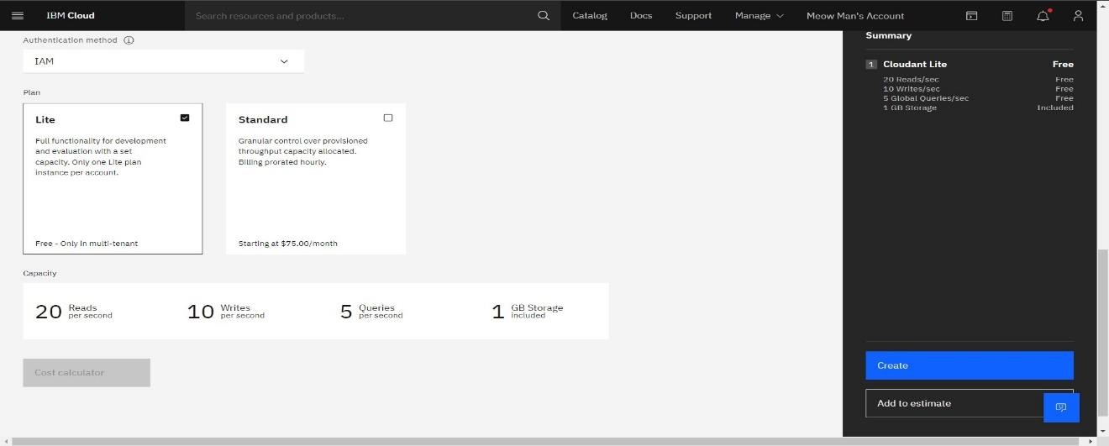

* The Cloudant database resource was created successfully

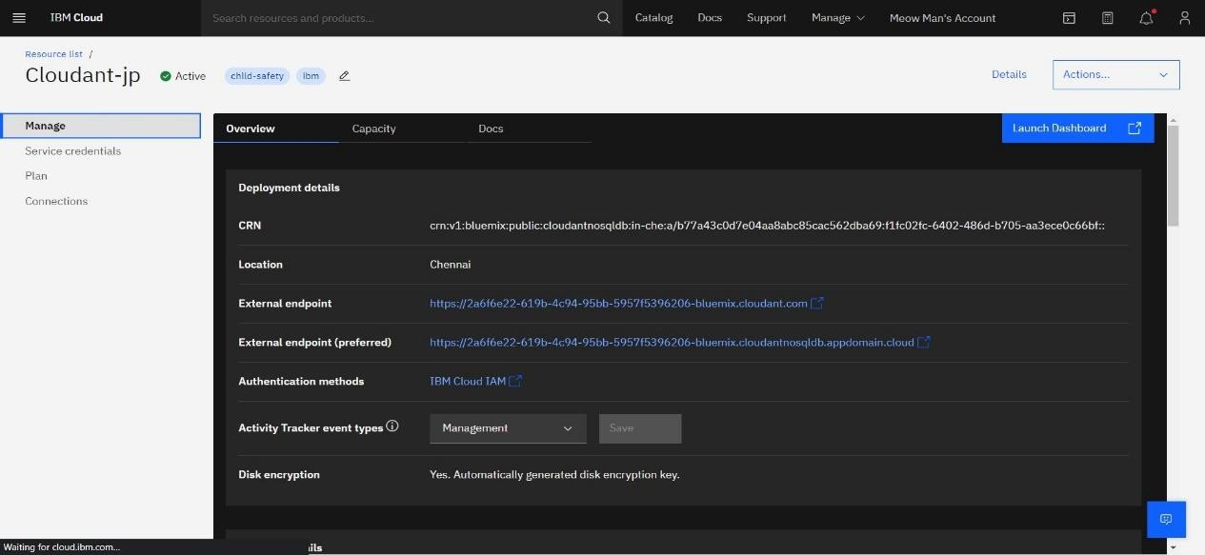

* Clicked on Launch Dashboard

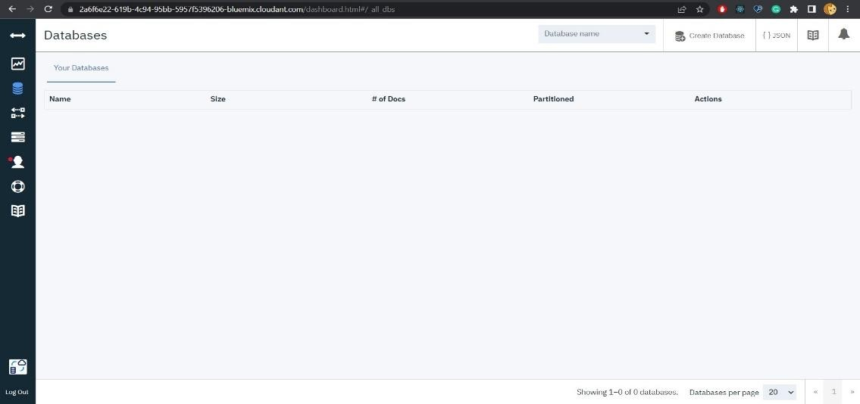

* Clicked on “Create Database”. Entered “meowman” as the database name and the “Non-partitioned” option

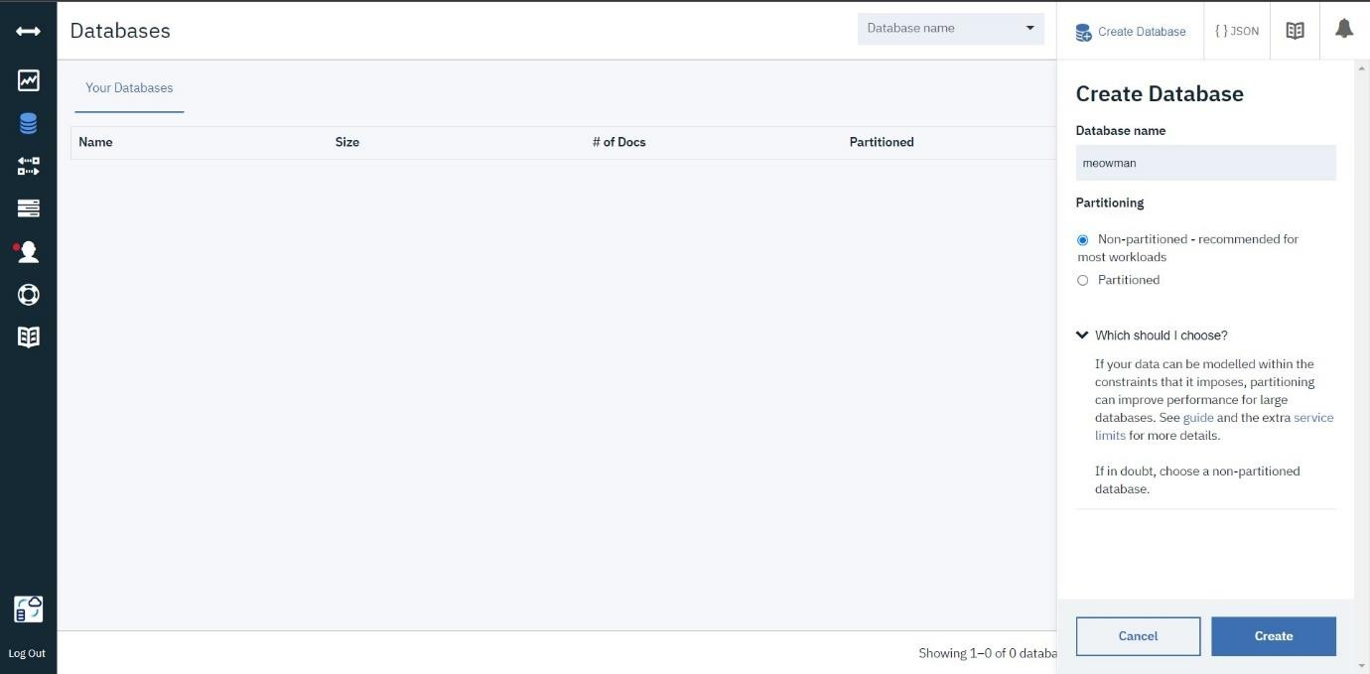

* The database “meowman” was created successfully

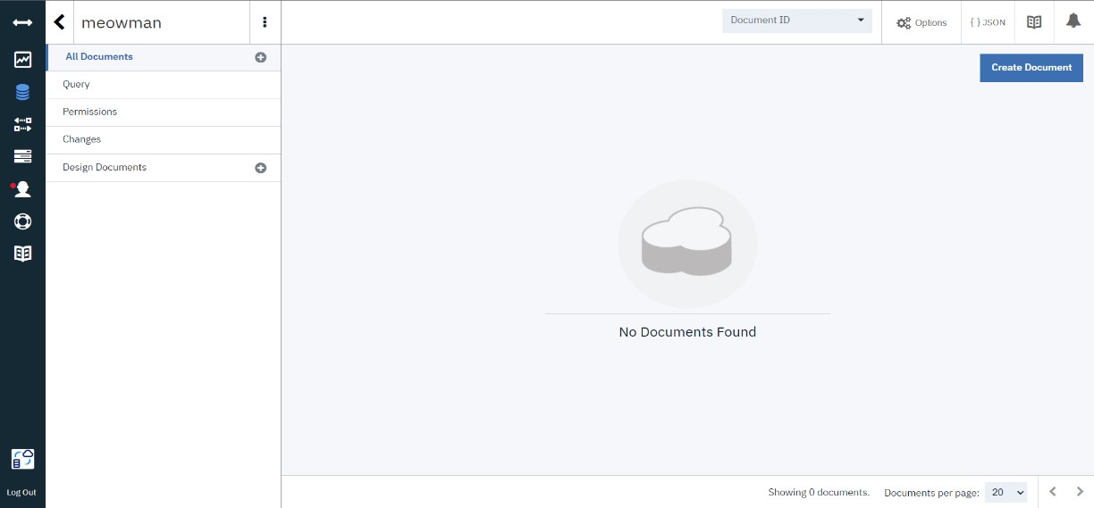

**Result:**

A database to store the location data was created successfully on Cloudant DB.